Flu 2020: Davyhulme Medical Centre Flu Plan
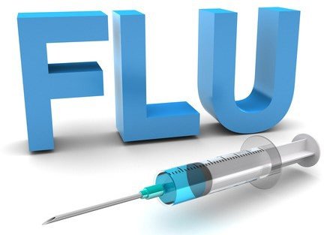
This year we have to factor in social distancing into our flu vaccination schedule and so we are introducing new systems to keep everyone safe. There will not be any drop-in flu clinics this year but lots of other safe options, and all patients MUST pre-book an appointment slot in advance.
Everyone eligible needs to pre-book one of the following options from 7th Sep onwards:
Who should get the flu vaccine?
This year the flu vaccine is being offered on the NHS to:
  - adults 65 and over (including anyone who will be 65 by the 31st March 2021)
  - people with certain medical conditions (including children in at-risk groups from 6 months of age)
  - pregnant women (vaccinations due mid September)
  - CARERS - including people living with someone who's at high risk from coronavirus (on the NHS shielded patient list)
  - children aged 2 and 3 on 31 August 2020 (vaccine should be available from mid-Sept)
  - children in primary school (n.b. these vaccines are available via the school ONLY)
  - children in year 7 (secondary school) (n.b. these vaccines are available via the school ONLY)
  - frontline health or social care workers
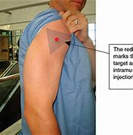
Come ready for your vaccination:
We need to access the top muscle of your arm
Please wear a short sleeve top that can easily
be rolled and have arm ready before entering the
room.

I am aged 50-64, am I also now eligible?
Later in the year, the flu vaccine is expected to be able to be given to people aged 50 to 64.
More information will be available to the 50-64 ‘newly eligible’ patients later in the autumn and until then, Davyhulme Medical Centre appointments are only being opened up to be booked by those patients who were already eligible. We have to prioritise vaccine stock for the most vulnerable patients first.
- If you're aged 50 to 64 but also in another at-risk group, you should book for your flu vaccine and not wait (bookings start from 7th September).
- If you’re aged 50 to 64 and were not already in an at risk group, please ensure the practice has a correct mobile number for you, as details will be sent by text about the availability of additional vaccines later in the season once vaccine supplies have been supplied from the NHS. Do not book now !
When are the flu appointments available to be booked into?
  - We shall start to open up appointments for booking into a flu vaccine clinic from 7th September 2020 onwards.
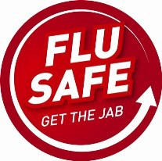
- W When do the flu clinics start?

  - The pre-booked clinics will be scheduled to start towards mid-September, once stock delivery dates are confirmed.

How to book:
If you are eligible:
- Ways to book:
  - AskmyGP, send in a request for flu appointment https://my.askmygp.uk/?c=P91013#/intro
  - Phone: 0161 748 5559 Our phone lines will be busy so please be patient.
If you are aged 50-64:
- If you do not have a long term condition, you shall only become eligible later in the season. We will text you when further details are announced, so please let us know if you recently changed your mobile number, update us via AskmyGP. Details will also be on our website page.

How to decline:
- If you already know that you don’t want a flu vaccine please tell us. You can do this via AskmyGP, on the tear off slip when you receive your letter and drop it into the box at the front door OR email to decline if that’s easier so that your vaccine can be offered to someone else who needs it: This year more than ever, this is very important as vaccines supplies are expected to be in extremely high demand. Email: davyhulmemedicalcentre@nhs.net

Come ready for your vaccination:

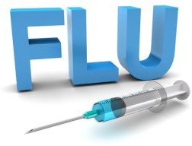
Flu 2020: Frequently Asked Questions

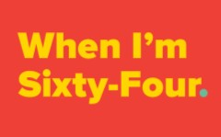
I am almost 65, am I eligible now?
Yes. As with previous years, anyone who will be 65 years old by the 31st March 2021 will be entitled to receive a flu vaccine from the 65+ supply even before they physically turn 65.

Can I have my flu vaccine when I am coming up the surgery for another medical reason? Yes, but only if you have an appointment and only if time allows on the day.
If an eligible patient is already coming to Boundary House for a face to face appointment with a GP, Nurse or HCA a flu vaccine can potentially be given if time allows on the day.
This will only apply to appointments after the following dates:
  - From 21st September for over 65’s and under 65’s ‘at risk’
  - From end November (we believe) for the newly eligible 50-64 year olds, awaiting further guidance.

Children should book to attend an appointment at the surgery.
We shall keep a very limited number of flu appointments at the surgery building which will be reserved for at-risk children. The vaccine should be available from mid-Sept , we shall text or write to you once delivery is confirmed.

- If your child is eligible to have a vaccination at school, but not otherwise in another at risk group, they should have their vaccine at school, not at the Doctors surgery.

Home visits are available - for medically housebound patients only. We shall continue to offer essential home visits for very frail patients to have their flu vaccinations at home and for those living in care homes.
- Home visit slots are very limited and so are strictly reserved only for those who physically couldn’t get into a car to attend an appointment with help from a friend, family or a taxi.

